Testing Different sensors using Arduino

Components used :

1. Bread Board.
2. PIR sensor.
3. IR sensor.
4. Arduino Uno.
5. Connecting Cables.

IR Sensor:

IR Infrared Obstacle Avoidance Sensor Module has a pair of infrared transmitting and receiving tubes. When the transmitted light waves are reflected back, the reflected IR waves will be received by the receiver tube. The onboard comparator circuitry does the processing and the green indicator LED comes to life.

The module features a 3 wire interface with Vcc, GND and an OUTPUT pin on its tail. It works fine with 3.3 to 5V levels. Upon hindrance/reflectance, the output pin gives out a digital signal (a low-level signal). The onboard preset helps to fine tune the range of operation, effective distance range is 2cm to 80cm.

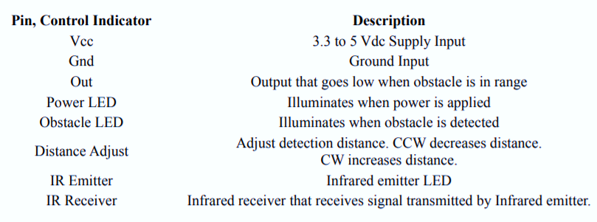

Code :

int sensorPin = 0; //analog pin 0

void setup(){

Serial.begin(9600);

}

void loop(){

int val = analogRead(sensorPin);

Serial.println(val);

//just to slow down the output - remove if trying to catch an object passing by

delay(100);

}

I placed an object at 20, 40, 60, and 80 cm from the sensor and got output values of around 260, 130, 110, and 80, respectively

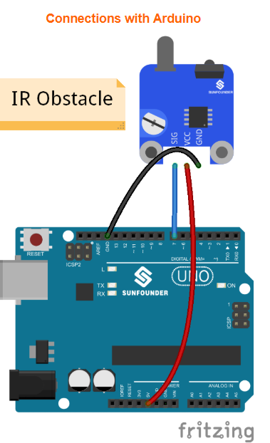

Applications:

Infrared sensors are used to sense characteristics in its surroundings by emitting and/or detecting infrared radiation and are capable of measuring the heat being emitted by an object and Detecting the motion.  
Some of the most important tools for maintaining a clean, safe, and healthy environment are sensors, sensor systems, and sensor networks that detect the presence and quantify the amount of specific chemical trace gases. Once the source is located, monitoring also provided by sensors supports mitigation and compliance.   
  
This is also true for industrial process and automotive monitoring and health, especially in breath analysis. Today’s standard expensive and time-consuming medical tests will give way to breathalyzers able to diagnose medical conditions on the spot. Medical care will become more proactive and remote care more accurate for today’s aging population.   
  
Infrared vision has several applications. It can visualize heat leaks in houses, help doctors monitor blood flow, identify environmental chemicals in the environment, allow art historians to see under layers of paint, and integrate it with contact lenses or wearable electronics.   
  
For optical communication, a modulated IR light beam transmitted by an emitter LED is received by a silicon photodiode. Infrared Data Association standards provide the basis for IR communication. IR technology is the most commonly used technique for remotely controlling appliances, an important aspect of its use in IoT and in connected-home applications

**PIR Sensor** [**(HC-SR501)**](https://makeradvisor.com/tools/pir-motion-sensor-hc-sr501/)**:**

The PIR motion sensor is ideal to detect movement. PIR stand for “Passive Infrared”. Basically, the PIR motion sensor measures infrared light from objects in its field of view.

So, it can detect motion based on changes in infrared light in the environment. It is ideal to detect if a human has moved in or out of the sensor range.

The sensor in the figure above has two built-in potentiometers to adjust the delay time (the potentiometer at the left) and the sensitivity (the potentiometer at the right).

Wiring the PIR motion sensor to an Arduino is pretty straightforward – the sensor has only 3 pins.

* GND – connect to ground
* OUT – connect to an Arduino digital pin
* 5V – connect to 5V

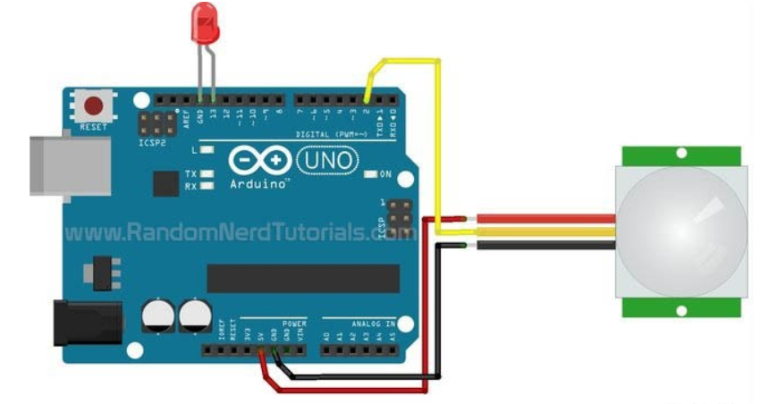

Code:

int led = 13; // the pin that the LED is atteched to

int sensor = 2; // the pin that the sensor is atteched to

int state = LOW; // by default, no motion detected

int val = 0; // variable to store the sensor status (value)

void setup() {

pinMode(led, OUTPUT); // initalize LED as an output

pinMode(sensor, INPUT); // initialize sensor as an input

Serial.begin(9600); // initialize serial

}

void loop(){

val = digitalRead(sensor); // read sensor value

if (val == HIGH) { // check if the sensor is HIGH

digitalWrite(led, HIGH); // turn LED ON

delay(100); // delay 100 milliseconds

if (state == LOW) {

Serial.println("Motion detected!");

state = HIGH; // update variable state to HIGH

}

}

else {

digitalWrite(led, LOW); // turn LED OFF

delay(200); // delay 200 milliseconds

if (state == HIGH){

Serial.println("Motion stopped!");

state = LOW; // update variable state to LOW

}

}

}

Application:

* PIR Sensor based Automatic Door Opening System

The main aim of this project is to opening and closing of doors,  in places wherein a person’s presence is mandatory – for instance, hotels, shopping malls, theaters,etc. this project consists of a PIR sensor that senses the presence of the human body and sends pulses to particular interface devices.

#### Security Alarm System based on PIR sensor

The main intention of this project is to provide security. This project is based on PIR sensor with an integrated circuit which generates a siren.

#### Human Detection Robot Using PIR Sensor

The human detection robot using PIR sensor mainly detects human, and it is based on an [8-bit microcontroller](https://www.elprocus.com/8051-microcontroller-architecture-and-applications/). A passive infrared sensors used to detect the human beings and this project is mainly used to rescue people stuck in debris during earthquake. It basically brings humans stuck under debris to the surface, thereby saving them effectively.